Project Documentation
Auto Ticket Classification using ServiceNow Flow Designer
Note: this project is built on the ServiceNow low-code platform. The MERN headings in the format (React, Node.js / Express, MongoDB, npm) are mapped to their ServiceNow equivalents, and every section of the format is kept.

1. Introduction
- Project Title: Auto Ticket Classification using ServiceNow Flow Designer
- Team Members:
Name | Role | Focus area
Dakshayani R N R | Team Lead | Requirements, data model and release sign-off
Harini Sri S | Member | Platform setup, table creation and documentation
Rubiga I | Member | Dependent choices and flow automation

2. Project Overview
- Purpose: Automatically assign Category and Subcategory to incidents raised at a school IT helpdesk and confirm each ticket to the caller, so staff no longer sort requests by hand.
- Features:
- Keyword-based auto classification of the Short Description.
- Dependent Subcategory choices that follow the selected Category.
- Automatic confirmation email to the caller.
- Auto-numbered tickets with prefix INC.
- Structured storage in a custom table.
- Portable update set for moving the solution between instances.

3. Architecture
- Frontend (ServiceNow UI in place of React): Users work in the standard ServiceNow form and list views of the Incident WorkFlow table, laid out with Form Designer. The Subcategory drop-down is filtered by the platform; no custom client scripts or UI code are used.
- Backend (Flow Designer in place of Node.js / Express): Server-side logic is a single flow, Auto Classify School IT Tickets. It starts on Record Created when Category is empty, evaluates If / Else If conditions on the Short Description, runs an Update Record action for the matching branch, and finishes with a Send Email action.
- Database (ServiceNow relational database in place of MongoDB): Tickets are rows of table u_incident_workflow with an auto-number (prefix INC). Caller references sys_user, and Assigned group and Assigned to reference sys_user_group and sys_user. Category, Subcategory and State are choice fields stored as choice records; Subcategory choices carry a dependent value that links each one to a Category. The full field list is in the Proposed Solution document.

4. Setup Instructions
- Prerequisites:
- A ServiceNow instance (for example a personal developer instance) and an account with the admin role.
- A current web browser.
- Flow Designer available on the instance.
- Outbound email configured, and users with valid email addresses.
- The exported update set XML file.
- Installation (import the update set):
1. Open All menus and search for Retrieved Update Sets.
2. Choose Import Update Set from XML, select the XML file and upload it.
3. Open the retrieved update set and click Preview Update Set; resolve any reported problems.
4. Click Commit Update Set.
5. Open Workflow Studio and confirm that the flow Auto Classify School IT Tickets is Active; click Activate if it is not.
6. Check System Properties > Email so that outbound mail is enabled.
Environment variables are not used. Instance-specific settings are the instance URL, user credentials and the email properties above.

5. Folder Structure
- Client (user interface artefacts):
Incident WorkFlow [u_incident_workflow]
|-- Form Design (default view)
| |-- Number, Caller, Category, Subcategory
| `-- Short description, Description, State,
| Assigned group, Assigned to
`-- List view

- Server (platform and automation artefacts):
Scope: Global | Update set: Project Update Set
|-- Table controls: auto-number INC,
| access role u_incident_workflow_user
|-- Dictionary: Subcategory dependent on Category
|-- Choice lists: Category, Subcategory, State
|-- Flow: Auto Classify School IT Tickets
| |-- Trigger: Record Created, Category is empty
| |-- If / Else If branches, Update Record
| `-- Send Email action
`-- System log: Emails

6. Running the Application
There is no local server to start. The application runs inside the ServiceNow instance:
1. Make sure the flow is Active in Workflow Studio.
2. Because the table was created with Create module unchecked, open its list by typing u_incident_workflow.list in the application filter and pressing Enter.
3. Click New, choose a Caller, enter a Short Description and submit.
4. Reload the record; Category and Subcategory are now filled in.
5. Check System Logs > Emails for the confirmation message.

7. API Documentation
The project adds no custom REST endpoints. ServiceNow exposes the table through its built-in Table API, and any record created this way also fires the flow. Because the flow runs after the insert, read the record again to see the classified values.
Method | Endpoint | Purpose and parameters
GET | /api/now/table/u_incident_workflow | List tickets. Parameters: sysparm_query, sysparm_limit, sysparm_fields.
GET | /api/now/table/u_incident_workflow/{sys_id} | Read one ticket.
POST | /api/now/table/u_incident_workflow | Create a ticket (triggers the flow). Body: caller, short_description.
PATCH | /api/now/table/u_incident_workflow/{sys_id} | Update fields of a ticket.
DELETE | /api/now/table/u_incident_workflow/{sys_id} | Delete a ticket.

Example request (illustrative values):
POST /api/now/table/u_incident_workflow
{ "caller": "<sys_id of caller>",
"short_description": "Network issue in the library" }

Example response after the flow has run (GET, shortened):
{ "result": {
"number": "INC00511",
"short_description": "Network issue in the library",
"u_category": "network",
"u_subcategory": "wi-fi" } }

Field names other than the table name and u_subcategory follow the usual u_ naming and should be confirmed on the instance.

8. Authentication
- Login: Users sign in to the instance with their ServiceNow account; the platform manages the session.
- Authorization: Access to the table is controlled by security rules created with it, using the role u_incident_workflow_user. Administrators carry out configuration.
- API access: Calls to the Table API use the instance's supported methods, such as basic authentication or OAuth tokens, and are subject to the same security rules.
- Flow execution: The flow acts on the record that triggered it; confirm its Run As setting in the flow properties before production use.

9. User Interface
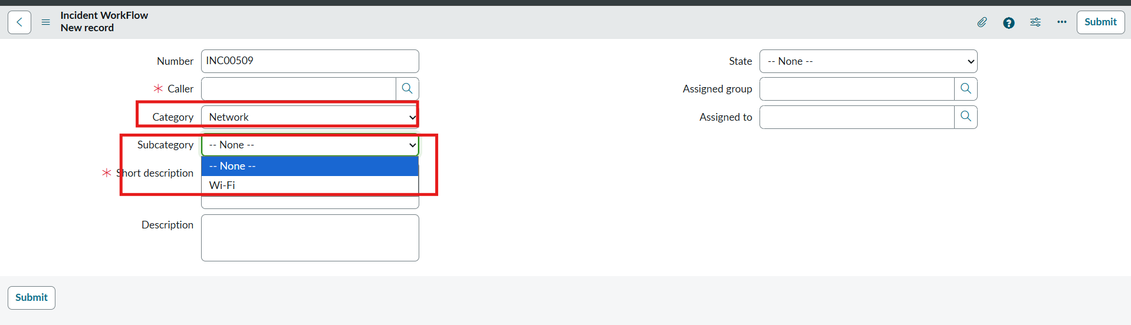
Figure 1: Category = Network limits Subcategory to Wi-Fi
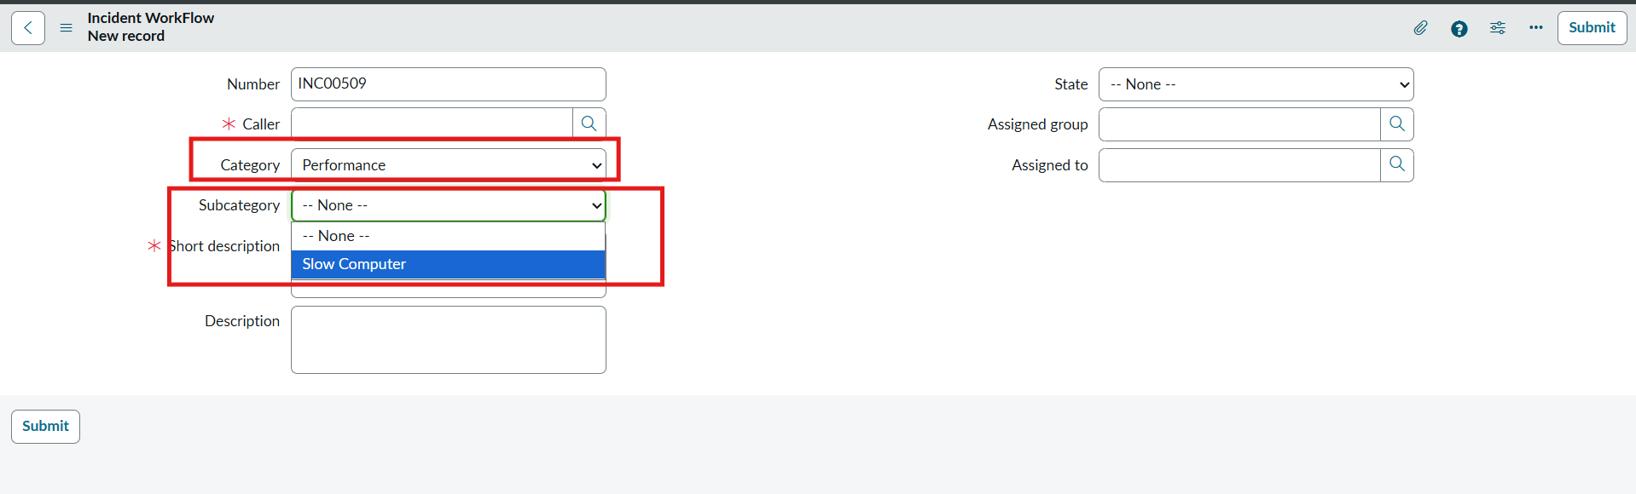
Figure 2: Category = Performance limits Subcategory to Slow Computer
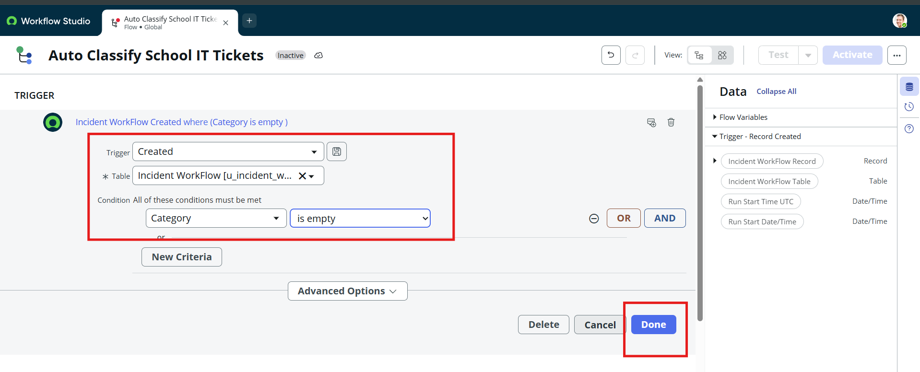
Figure 3: Flow trigger: Record Created on Incident WorkFlow where Category is empty
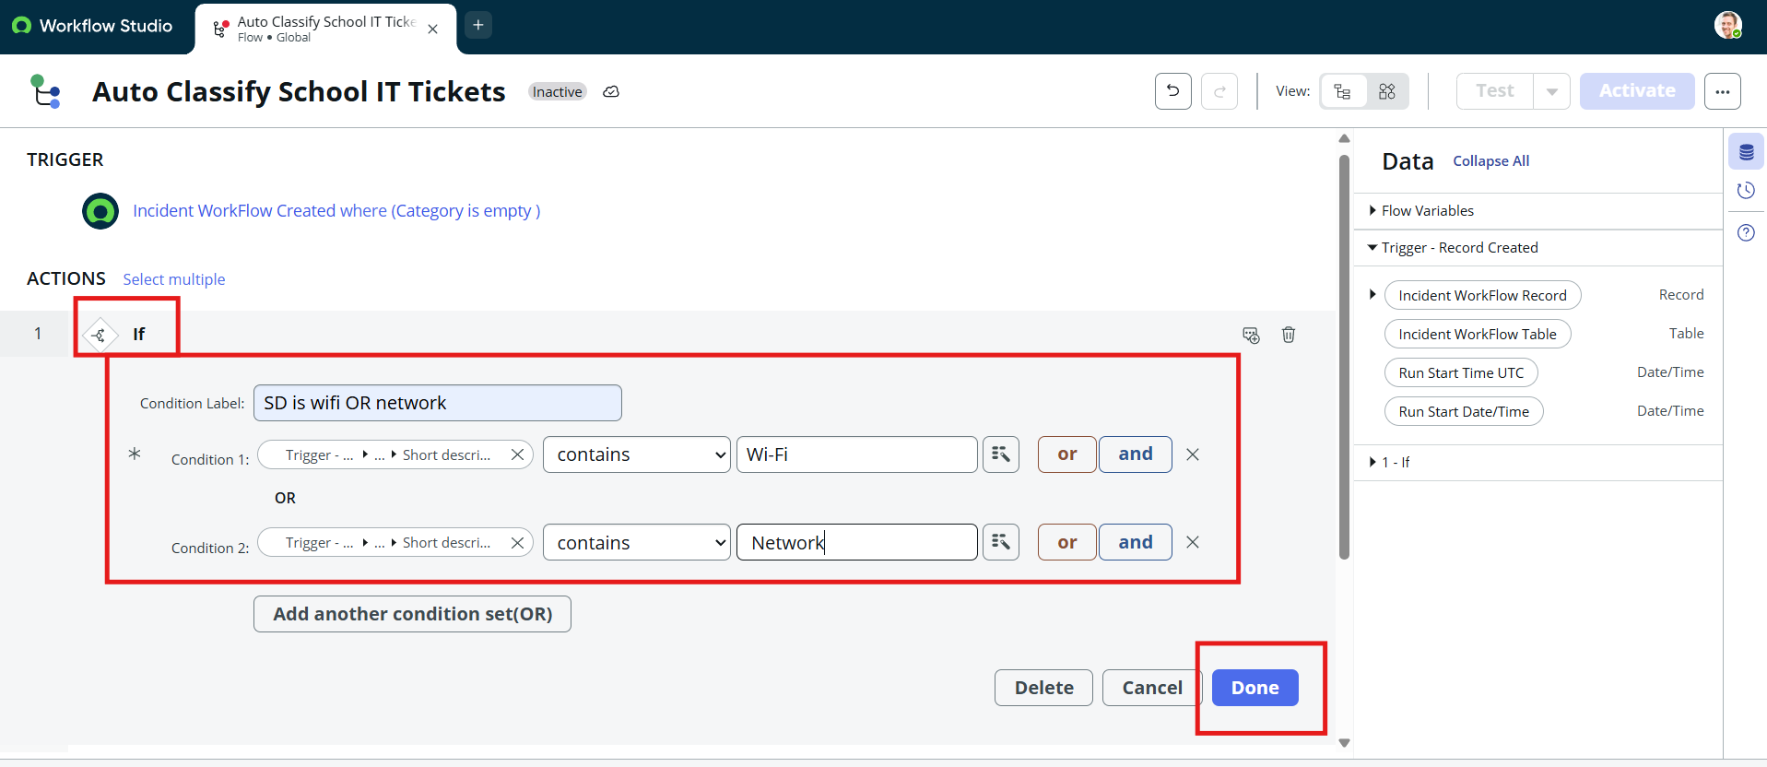
Figure 4: If condition matching Wi-Fi or Network in the Short Description

10. Testing
Testing was manual and functional, performed in the browser on the live instance.
- Strategy: create tickets with typical descriptions, reload them, and compare Category and Subcategory with the expected values; then confirm the notification.
- Tools: the Incident WorkFlow form, Workflow Studio, and System Logs > Emails with Preview mail.
- Data checks: mandatory fields, unique auto-numbers, stored choice values and reference fields.
Recorded results are in the Solution Architecture document and the Final Report.

11. Screenshots or Demo
- Demo link: [Add demo link]
Suggested demo order:
1. Show the table form and the dependent Subcategory list.
2. Open the flow and walk through the trigger and branches.
3. Create a ticket with only Caller and Short Description.
4. Reload it to show the filled Category and Subcategory, then open the email log.
Result screenshots appear in section 7.1 of the Final Report.

12. Known Issues
Issue | Detail
Spelling variants | The first rule looks for "Wi-Fi" or "Network". A description written as "WiFi" does not match unless it also contains "Network".
No fallback | If no keyword matches, Category and Subcategory stay empty and the ticket needs manual handling.
First match wins | Branches run in order, so a description with several keywords takes the first branch only.
Planned keywords not built | The plan also lists Password, Login, Slow and Hanging, but the flow checks only Forgot password and Slow computer.
Create only | The trigger fires on record creation; later edits to the description are not re-classified.
Email wording | The sample email contains placeholder wording ("xyz college") and informal phrasing that should be edited.
Branch label | The projector branch is labelled "projector OR hardware" but tests only for Projector.

13. Future Enhancements
- Add keyword variants and spellings (WiFi, Wi Fi, Login, Hanging) to existing branches.
- Add a default branch that sets a general category and flags the ticket for review.
- Run the flow when the Short Description changes, not only on creation.
- Move keyword lists into a decision table so rules can be edited without touching the flow.
- Publish a portal or service catalogue form for requesters.
- Revise the confirmation email to include the ticket number, category and school name.

